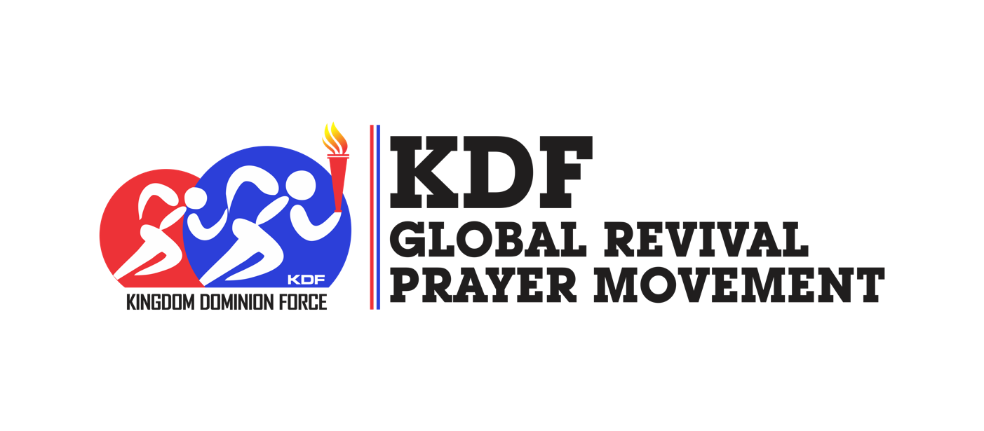

**KINGDOM DOMINION FORCE GLOBAL REVIVAL PRAYER MOVEMENT PRAYER BULLETIN – DAY 398**

***(Spend a minimum of 5 Minutes on each prayer)***

**Psalm 103:2-3**

***Bless the Lord, O my soul, and forget not all his benefits: Who forgiveth all thine iniquities; who healeth all thy diseases; Who redeemeth thy life from destruction; who crowneth thee with lovingkindness and tender mercies;***

* Faithful God, we thank you for your protection, preservation and provisions. You have been faithful. Thank you, Father.
* Gracious God, we thank you for your healing grace made available to us.

**2 Corinthians 4:4-6**

***In whom the god of this world hath blinded the minds of them which believe not, lest the light of the glorious gospel of Christ, who is the image of God, should shine unto them. For we preach not ourselves, but Christ Jesus the Lord; and ourselves your servants for Jesus' sake. For God, who commanded the light to shine out of darkness, hathshined in our hearts, to give the light of the knowledge of the glory of God in the face of Jesus Christ.***

* God, we command every captive of the devil set free, in the name of Jesus Christ.
* Let the light of the gospel shine in every heart now, in the name of Jesus Christ.
* Every resistance to the word of God is scattered, in the name of Jesus Christ.

**Psalm 13:2-4**

***How long wilt thou forget me, O Lord? for ever? how long wilt thou hide thy face from me? How long shall I take counsel in my soul, having sorrow in my heart daily? how long shall mine enemy be exalted over me? Consider and hear me, O Lord my God: lighten mine eyes, lest I sleep the sleep of death; Lest mine enemy say, I have prevailed against him; and those that trouble me rejoice when I am moved.***

* O Lord, manifest your glory in our families, ministries and businesses, in the name of Jesus Christ.
* Arise, o God, let your power prevail against those who armed themselves against the church of Christ, arise o God, in the name of Jesus Christ.
* Lord, turn them back in shame who seek the destruction of the righteous, in the name of Jesus Christ.
* Heavenly Father, I thank you for putting my enemies to shame.
* Gracious God, I bless your name. You have lightened up my days, thank you Jesus.